Modulation Recognition: Handcrafted Features vs CNN
Chapter 3 assignment, option 2: classify BPSK, QPSK, 16-QAM and 64-QAM

1. Task and Scenario
A receiver gets a burst of symbols with an unknown modulation and must classify it as BPSK, QPSK, 16-QAM or 64-QAM. Symbol timing is assumed recovered (one sample per symbol), and each sample is a window of 128 symbols. The objective is high accuracy across SNR and channel conditions, including conditions not seen in training.

2. Signal Model and Data
- Model: r[n] = h·exp(j(2πfn + φ))·s[n] + w[n], with unit-power symbols s[n], a flat block-fading gain h (constant within a burst), unknown phase φ ~ U(0, 2π), carrier-frequency offset (CFO) f, and noise w ~ CN(0, 10^(−SNR/10)). Each window is normalized to unit power (AGC).
- Channels: AWGN (h = 1), Rayleigh (h ~ CN(0,1)) and Rician (K = 6 dB), with E|h|² = 1 so that SNR is the average SNR.
- Training data: AWGN and Rayleigh, SNR −5 to 20 dB in 5 dB steps, no CFO. 150 bursts per modulation, SNR and channel; each burst gives 4 windows (28,800 windows in total).
- Unseen test conditions: Rician fading, SNR from −10 to 30 dB (below and above the training range), and CFO up to 0.005 cycles/symbol at 15 dB. These test sets are generated fresh with a separate random stream.

3. Features, Baseline and ML Method
- Baseline: seven handcrafted features (|C20|, |C40|, |C41|, C42, E|r|⁴, E|r|⁶, std of |r|), which ignore the unknown phase, classified by a 200-tree random forest.
- ML method: a small CNN (38,980 parameters, three conv blocks) on a 32×32 constellation image, a 2-D histogram of the received I/Q points. The CNN suits the task because the information is the shape of the point cloud. Training used Adam for 15 epochs, with the epoch chosen on validation bursts.
- Both methods use the same windows, splits and test sets, so only the classifier differs.

4. Metrics and Leakage Prevention
- Metrics: accuracy vs SNR, confusion matrices at 0, 10 and 20 dB, and accuracy vs CFO. All experiments use 3 seeds (0, 1, 2) and are reported as mean ± std.
- Leakage prevention: the 4 windows of a burst share the same channel gain, phase and SNR, so the pool is split by whole burst (60/20/20), and the code asserts no burst appears in two splits. The CNN epoch is selected on validation bursts only, and no preprocessing is fitted on test data.

5. Results
Condition (accuracy %) | Baseline: cumulants + RF | Proposed: CNN
Held-out bursts (training conditions) | 65.3 ± 0.7 | 68.1 ± 0.7
AWGN, 0 dB | 48.1 ± 1.8 | 48.5 ± 1.1
AWGN, 10 dB | 72.5 ± 1.1 | 74.8 ± 0.2
AWGN, 20 dB | 89.8 ± 1.0 | 97.5 ± 0.8
Rayleigh, 20 dB | 84.3 ± 1.7 | 93.0 ± 2.0
Rician (unseen), 20 dB | 87.6 ± 1.1 | 96.4 ± 1.9
AWGN, 30 dB (above training range) | 86.9 ± 2.4 | 97.5 ± 1.9
AWGN, −10 dB (below training range) | 28.3 ± 1.0 | 26.8 ± 1.0
CFO max 0.001, AWGN 15 dB | 84.4 ± 0.5 | 93.9 ± 0.1
CFO max 0.002, AWGN 15 dB | 81.7 ± 0.4 | 86.2 ± 0.7
CFO max 0.005, AWGN 15 dB | 67.2 ± 0.8 | 67.1 ± 0.7
Mean ± std over 3 seeds. Chance level is 25%.
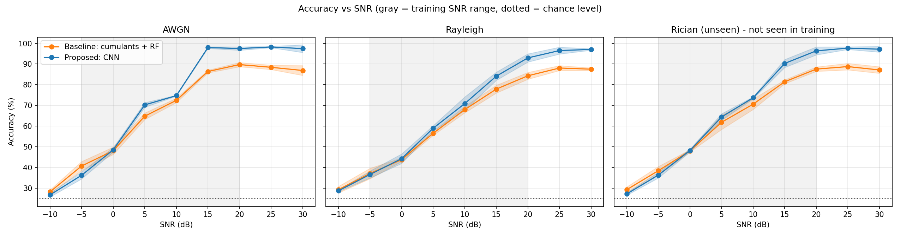
Accuracy vs SNR (shaded: training range). Baseline in orange, CNN in blue.
- The CNN is clearly better at medium to high SNR (about +8 to +9 points at 20 dB on AWGN, Rayleigh and unseen Rician), and about equal to the baseline at 0 dB and below.
- Fading lowers accuracy (Rayleigh 20 dB: 93.0% vs 97.5% on AWGN) because a deep fade lowers the effective SNR of a whole burst. The unseen Rician channel behaves like AWGN, so the CNN generalized across these fading types.
- Leakage check (seed 0): a random window split raised accuracy from 62.7% to 63.9% for the baseline and from 64.8% to 67.5% for the CNN, although 4,114 bursts were shared between train and test. The effect is modest, but it shows that a random split overstates performance.
- Cost: the CNN needs 0.19 ms per window vs 0.04 ms for the baseline (including feature or image creation).

6. Failure Analysis
- Low SNR, constellation overlap: at 0 dB, noise blurs the points of QPSK, 16-QAM and 64-QAM into one cloud. BPSK is still recognized perfectly, but the CNN labels 82% to 86% of the other three classes as 64-QAM, and the baseline spreads its errors among them. At 10 dB, 16-QAM and 64-QAM are still confused (the CNN labels 95% of 16-QAM as 64-QAM), and at 20 dB the CNN separates all classes except some 64-QAM errors.
- CFO: with no CFO in training, accuracy drops as the offset grows (CNN 97.9% at 0, 86.2% at 0.002, 67.1% at 0.005) because the rotating constellation smears into rings. Both methods fail the same way at large CFO, which points to the signal physics, not the classifier.
- SNR outside the training range: at −10 dB both methods are near chance (about 27%). At 30 dB the CNN stays at 97.5%, but the baseline stays at 86.9%, most likely because 128 symbols give noisy cumulant estimates for 16-QAM and 64-QAM.

7. Limitations
- All data is simulated: flat block fading, no frequency selectivity, perfect symbol timing, no phase noise or hardware impairments, and no CFO in training.
- Closed set of four classes, with no rejection of unknown signals; one feature set and one CNN size were tried.
- Next steps: train with CFO and run a CFO estimator first, add an unknown-signal reject class (open-set AMC), and test on measured signals.

8. Code Appendix
Code: modulation_recognition_assignment.ipynb (Google Colab, runs with Runtime > Run all; about 6 minutes on CPU). All parameters are in the first code cell: seeds 0, 1, 2; 128 symbols per window; training SNR −5 to 20 dB; 150 bursts per cell; 15 epochs; batch 128; learning rate 1e-3. Software: Python 3.12, NumPy 2.4, scikit-learn 1.8, PyTorch 2.14. The notebook writes results_main_table.csv and the figures fig_accuracy_vs_snr.png, fig_confusion.png, fig_cfo.png and fig_leakage_training.png.

